SALES AGREEMENT

To order:
- Fill in the information below.
- Sign and Date the Agreement.
- Save a copy of this Agreement as PDF as year-month-day-PO-Name-Institution-Eusera.pdf
(e.g. 2017-02-16-PO-YourName-UBC-Eusera.pdf)
- E-mail the PDF to luc.berthiaume@eusera.com
- Attach a Purchase Order, if applicable.

Direct any questions by e-mail to luc.berthiaume@eusera.com

Between:

Eusera
10061, 90 avenue NW
Edmonton, Alberta, Canada, T6E 4X2
(hereinafter called "the Vendor ")

And:

Please complete the following:
Name:
Institution/Company:
Division/Department:
Street/Address:
City/Province/State:
Postal code/Zip Code:
Country:
Phone:
Fax:
E-mail:
Your Fed Ex #:

Purchase Order # (if applicable):

Do you require an invoice? Yes_X___ No____

Choose payment option: Check ____ or Wire Transfer* _____
(*Wire transfer information will be provided on the Eusera invoice)

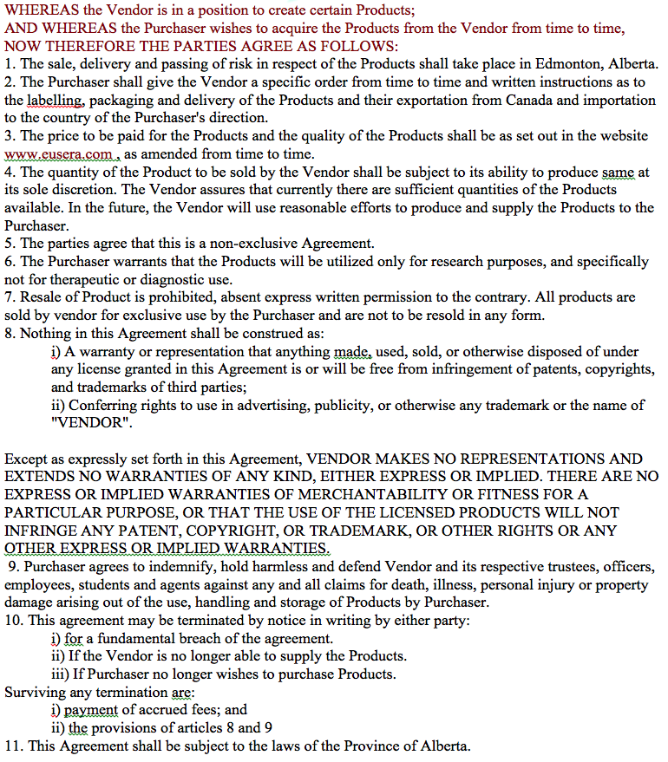

Product list:
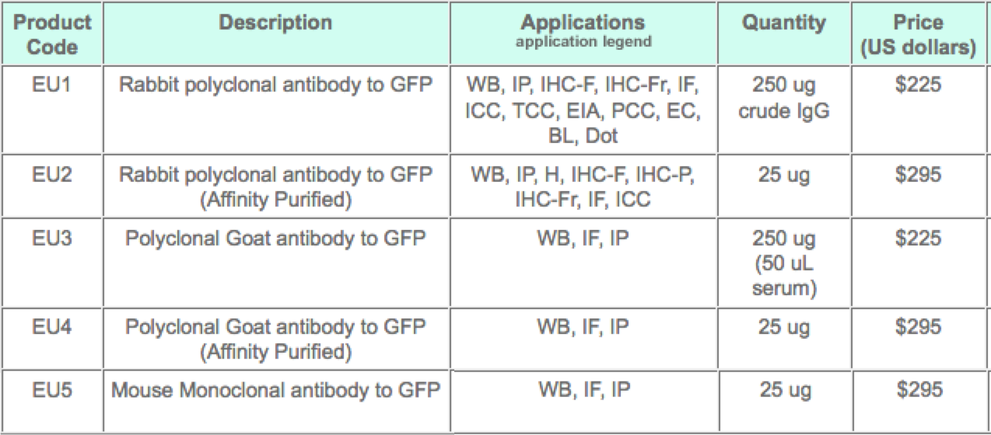

For further information on either product, please visit www.eusera.com

12. Purchase Information:
Please enter the Product code, Description, Price/Unit Number an d Number of Units ordered:

Product code | Description | Quantity  (ug/ul) | Number of Units ordered | Price per unit | Total amount  U.S.$
Sub-Total: ____________
5% GST: ____________

Total: ____________

This Agreement EXECUTED as of this date: _____________

Purchaser:__________________ Vendor: Eusera

Name (Print): ______________ Name (Print): Luc Berthiaume, Ph.D.

Title: _____________________ Title: Owner

Signature: ________________ Signature: __________________

Date: _____________________ Date: _________________________

Direct any questions by e-mail to luc.berthiaume@eusera.com

